**Module 06 Assignment**

1. Draw an ERD containing *Student* and *Paper* entity types connected by a 1-M relationship. The *Student* entity type should have attributes for *StdNo* (primary key), *StdFirstName*, *StdLastName*, *StdAdmitSemester*, *StdAdmitYear*, and *StdEnrollStatus* (full or part-time). The Paper entity type should have attributes for *PaperNo* (primary key), *PaperTitle*, *PaperSubmitDate*, *PaperAccepted* (yes or no), and *PaperType* (first, second,proposal, or dissertation). Add a 1-M relationship from *Student* to *Paper*.

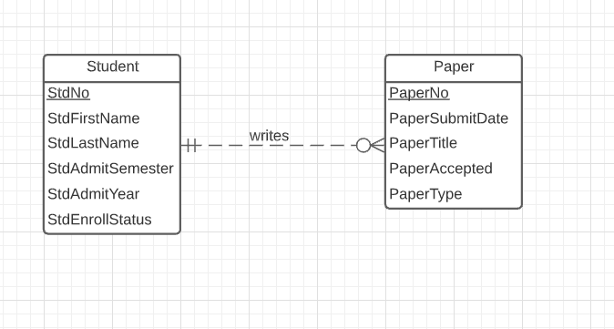

2. Extend the ERD from problem 1 with an *Evaluator* entity type and an M-N relationship between *Paper* and *Evaluator*. The Evaluator entity type should have attributes for *EvalNo* (primary key), *EvalFirstName*, *EvalLastName*, *EvalEmail*, and *EvalOffice*. The M-N relationship should have attributes for *EvalDate*, *EvalLitReview* (1 to 5 rating), *EvalProbId* (1 to 5 rating), *EvalTechWriting* (1 to 5 rating), *EvalModelDev* (1 to 5 rating), *EvalOverall* (1 to 5 rating), and *EvalComments*.

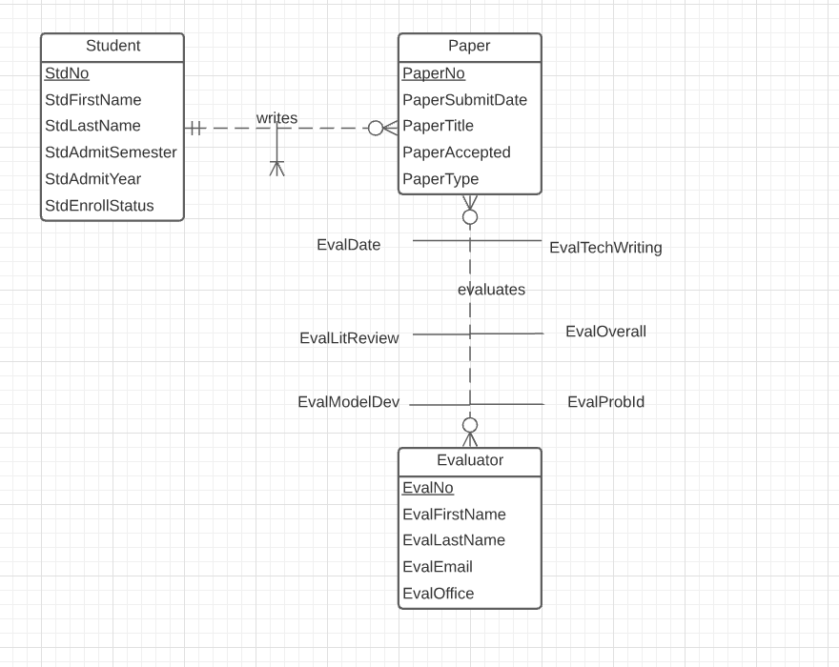

3. Transform the M-N relationship from problem 2 into an associative entity type and identifying relationships.

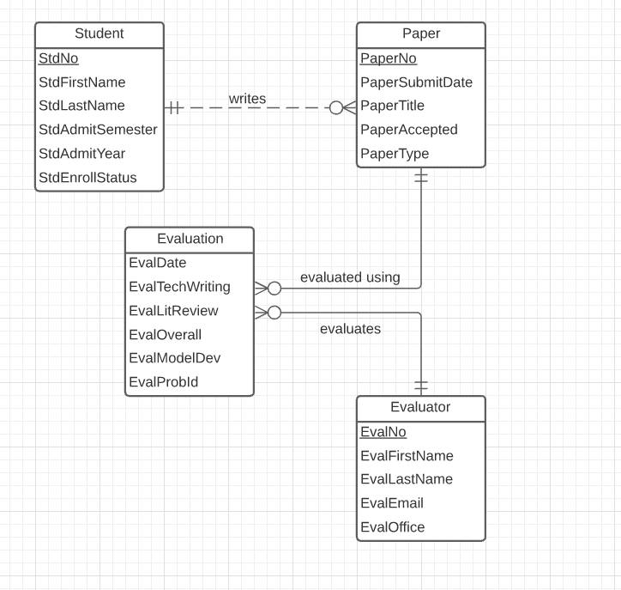

**Module 07 Assignment**

1. Draw an ERD containing the *Order* and *Customer* entity types connected by a 1-M relationship from *Customer* to *Order*. Choose an appropriate relationship name using your common knowledge of interactions between customers and orders. Define minimum cardinalities so that an order is optional for a customer and a customer is mandatory for an order. For the *Customer* entity type, add attributes *CustNo* (primary key), *CustFirstName*, *CustLastName*, *CustStreet*, *CustCity*, *CustState*, *CustZip*, and *CustBal* (balance). For the *Order* entity type, add attributes for the *OrdNo* (primary key), *OrdDate*, *OrdName*, *OrdStreet*, *OrdCity*, *OrdState*, and *OrdZip*. If you are using a data modeling tool that supports data type specification, choose appropriate data types for the attributes based on your common knowledge.

All data types should be variable length character strings (VARCHAR) except for CustNo, OrdNo, and OrdDate. CustNo and OrdNo should be INTEGER. OrdDate can be either DATE or TIMESTAMP (include time and date).

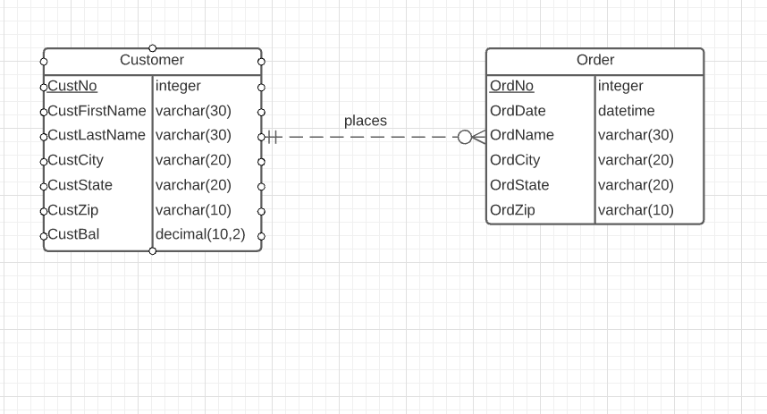

2. Extend the ERD from problem 1 with the *Employee* entity type and a 1-M relationship from *Employee* to *Order*. Choose an appropriate relationship name using your common knowledge of interactions between employees and orders. Define minimum cardinalities so that an employee is optional to an order and an order is optional to an employee. For the *Employee* entity type, add attributes *EmpNo* (primary key), *EmpFirstName*, *EmpLastName*, *EmpPhone*, *EmpEmail*, *EmpCommRate* (commission rate), and *EmpDeptName*. If you are using a data modeling tool that supports data type specification, choose appropriate data types for the attributes based on your common knowledge.

All data types should be variable length character strings (VARCHAR) except for EmpNo and EmpCommRate. EmpNo should be INTEGER, and EmpCommRate should be DECIMAL.

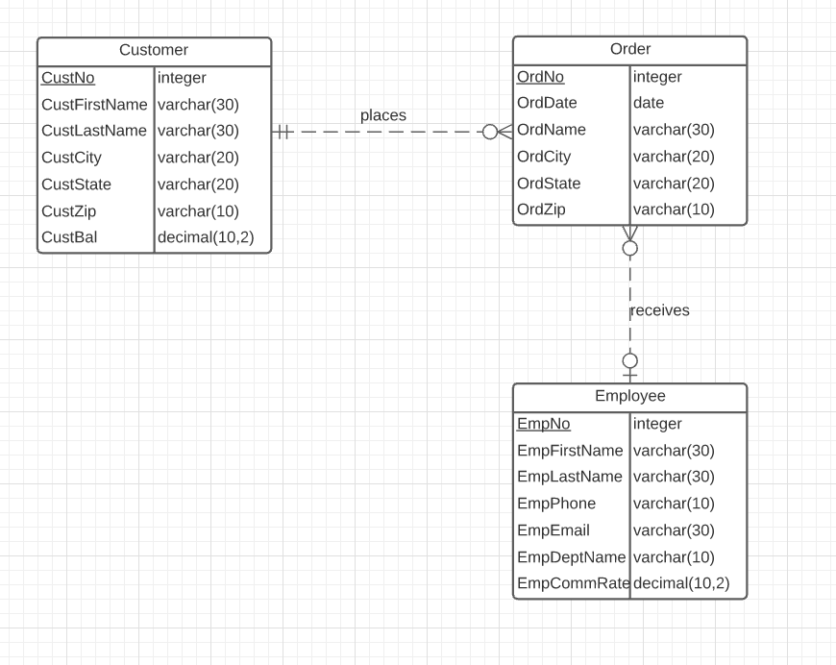

3. Extend the ERD from problem 2 with a self-referencing 1-M relationship involving the *Employee* entity type. Choose an appropriate relationship name using your common knowledge of organizational relationships among employees. Define minimum cardinalities so that the relationship is optional in both directions. In the slides, problem 3 is combined with problem 2.

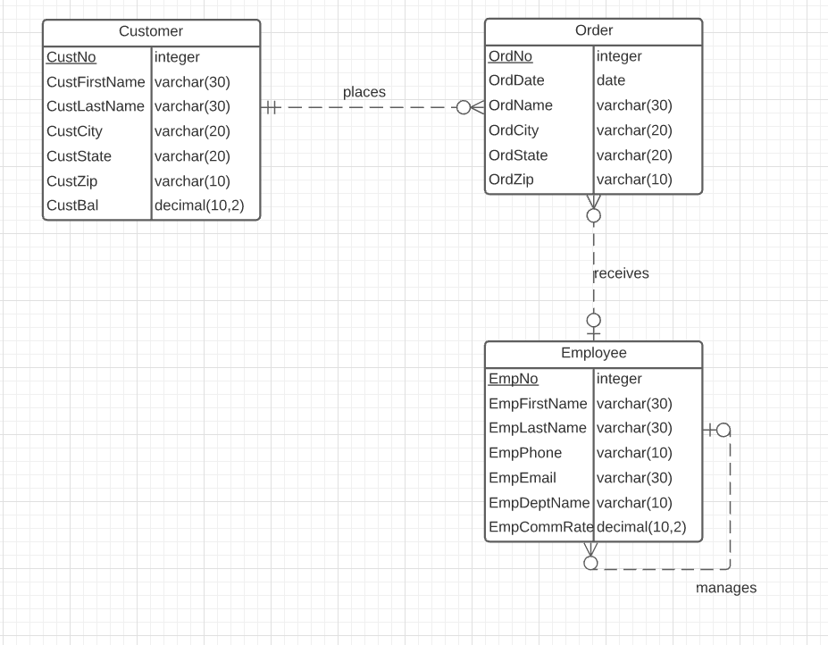

4. Extend the ERD from problem 3 with the *Product* entity type and an M-N relationship between *Product* and *Order*. Choose an appropriate relationship name using your common knowledge of connections between products and orders. Define minimum cardinalities so that an order is optional to a product, and a product is mandatory to an order. For the *Product* entity type, add attributes *ProdNo* (primary key), *ProdName*, *ProdQOH*, *ProdPrice*, and *ProdNextShipDate*. For the M-N relationship, add an attribute for the order quantity. If you are using a data modeling tool that supports data type specification, choose appropriate data types for the attributes based on your common knowledge.

For data types, ProdNo should be INTEGER, ProdName should be VARCHAR, ProdQOH should be INTEGER, ProdPrice should be fixed decimal (DECIMAL) with two digits to the right of the decimal point, and ProdNextShipDate should be DATE or DATETIME.

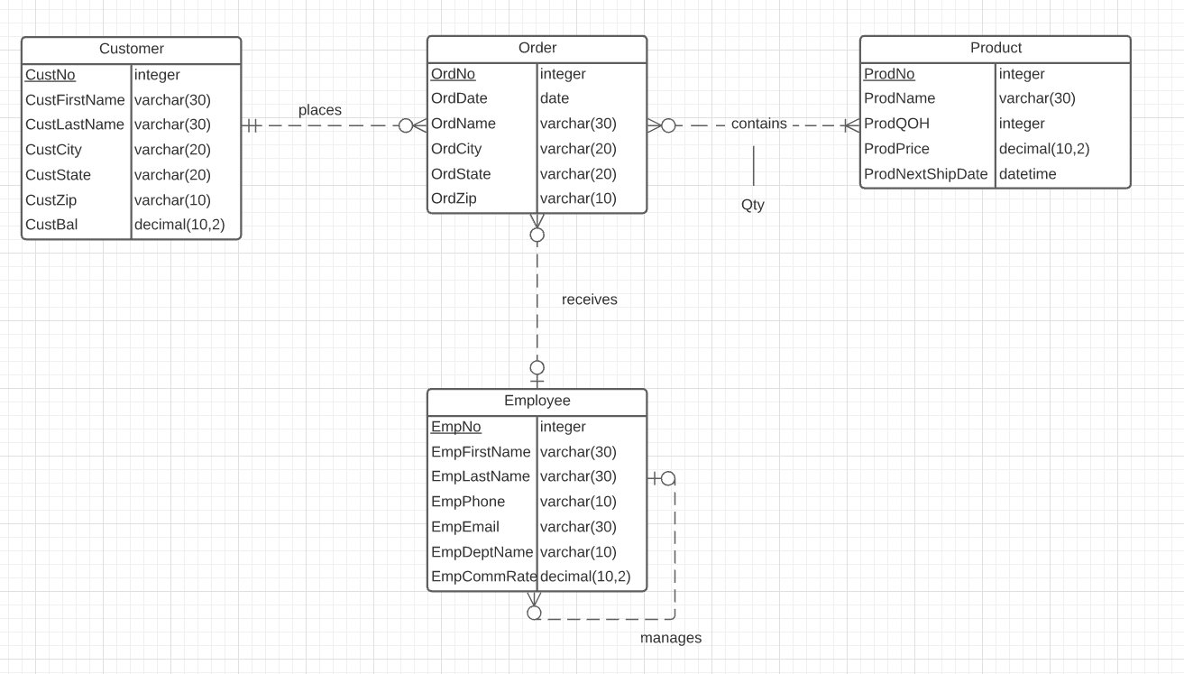

5. Revise the ERD from problem 4 by transforming the M-N relationship into an associative entity type and two identifying, 1-M relationships.

